Data Engineering Design Document
Data Quality Framework
Version 1 |

Table of Contents
1. Document Overview 2
1.1 Background 2
1.2 Goals (Requirements) 2
1.3 Scope 2
2. Background and Context 3
3. Design Decisions 3
4. Assumptions 3
5. Proposed Solution 3
5.1 High-Level Design 3
5.2 Business Benefits: 5
6. Detailed Design 6
6.1 Execution Logic 6
6.2 Automated Rule Generation (LLM Based) 6
6.4 Rule Definitions 6
SQL query used for validation. Supports dynamic placeholders: {catalog_name}, {schema_name}, {table_name} 17
6.5 Error Handling & Remediation 17
6.6 Schema Evolution 18
7. Observability and Alerting 18
7.1 Dashboarding 18
7.2 Alerting Strategy 18
8. Implementation Plan 19
8.1 Setup 19
8.2 Operational Workflow 19
8.3 CI/CD implementation 19
9. Appendix 19
1. Glossary and Acronyms 19
2. Rule Categories 19
3. Lakewatch Dashboard 20

1. Document Overview

1.1 Background
In current data environments, business and domain-specific data issues often go undetected. While native tools provide insights, they often lack enforcement and actionability. Analysts and engineers lack transparency and control over data quality failures.

1.2 Goals (Requirements)
The primary purpose is to provide an end-to-end data quality (DQ) framework covering the full lifecycle: Rule Creation (Manual & AI) → Approval → Execution → Results → Monitoring & Alerting.
Specific requirements include:
- Rule-based Validation: A robust system for defining and enforcing data rules.
- Unified View: Centralized visibility of rule results, logs, quarantine records, and trends.
- Operational Hooks: Ability to fail jobs,Delete bad records from main table trigger alerts, and isolate bad data.
- RCA Support: Enable Root Cause Analysis (RCA) and improve business understanding of data issues.
- UI-Based Management: A user interface for defining rules directly on tables
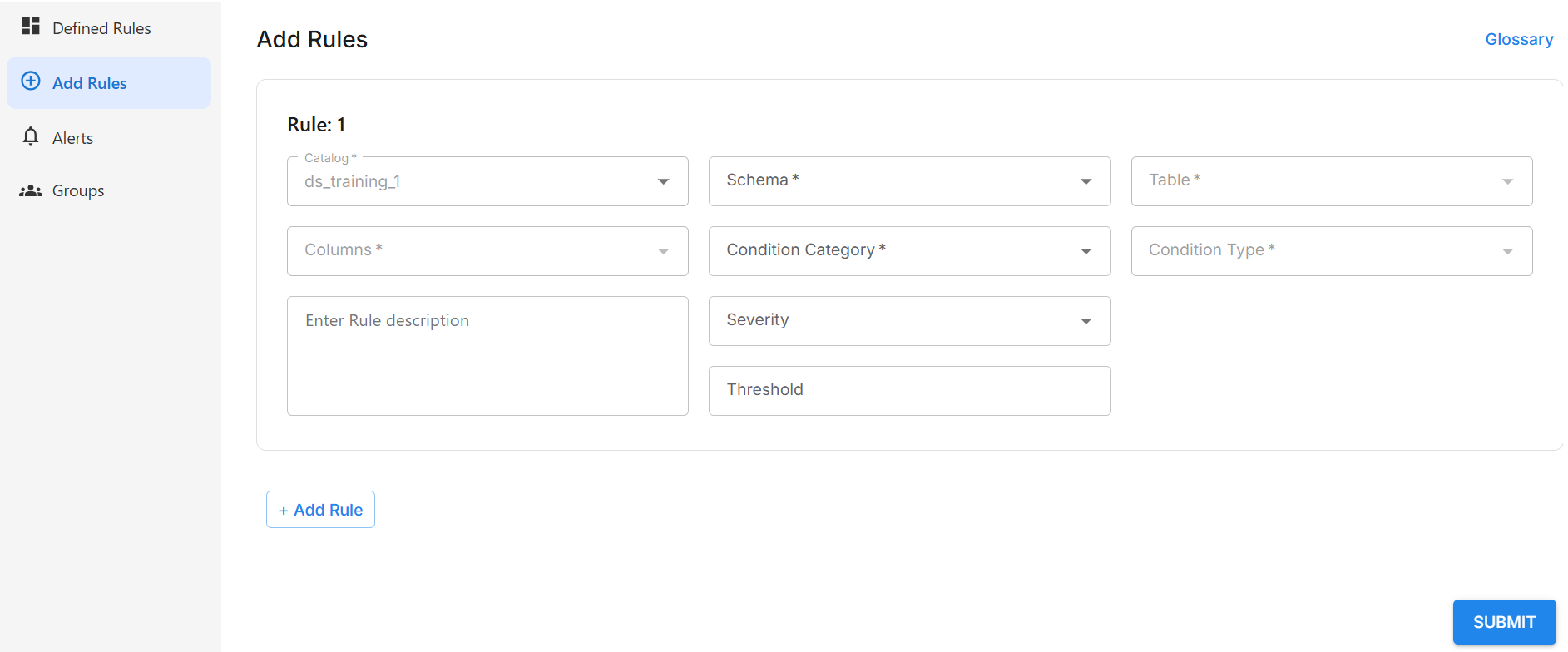

1.3 Scope
- Target Platform: Databricks Native.
- Core Pillars: Governance, Execution, and Observability.

Intended Audience:
- AirLife Data Engineering Team
- AirLife Data Architects
- AirLife IT Team
- Project Managers

2. Background and Context
Poor Data with bad records results in wrong numbers during reporting and Analysis.
Data quality when implemented results in correct data analysis and reporting to the stakeholders.

This Data Quality will be the part of the ingestion framework where DQ checks will be applied on the ingested Bronze layer table.

3. Design Decisions
- The primary design decision for this Data quality framework will be to provide lowest latency so that the data is checked on its quality but also there should not be any delay to write it to different layers (bronze, silver and gold)
- The Data from the target (Bronze layer) will be read based on timestamp based on the assumption that we have a “processed_timestamp” column in all bronze target tables.
- In general, we are planning to have rules for 20 priority tables.

4. Assumptions
This design is based on the following set of assumptions.
- Data Access: We assume a proper read access is given to implement proper DQ checks .
- Documentation Accuracy: we assume that the provided Data Model and Data dictionaries etc are reasonably accurate and reflect the current state.
- Data Source Stability: We assume the schemas of the in-scope source systems will not undergo major changes during the design and implementation phase of this project.
- Environment Parity: We assume the Development environment is sufficient functional replicas of the Production environment to ensure meaningful testing.
- Data or Target pipeline table: We are assuming that there is a processed timestamp column in the bronze layer.

5. Proposed Solution

5.1 High-Level Design
System Architecture
The system is designed around three modular pillars that interact to ensure data integrity.
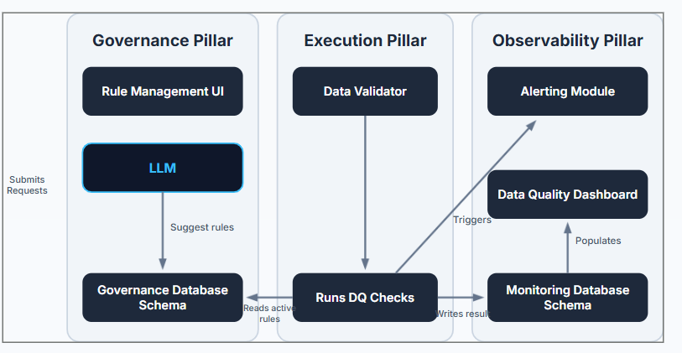

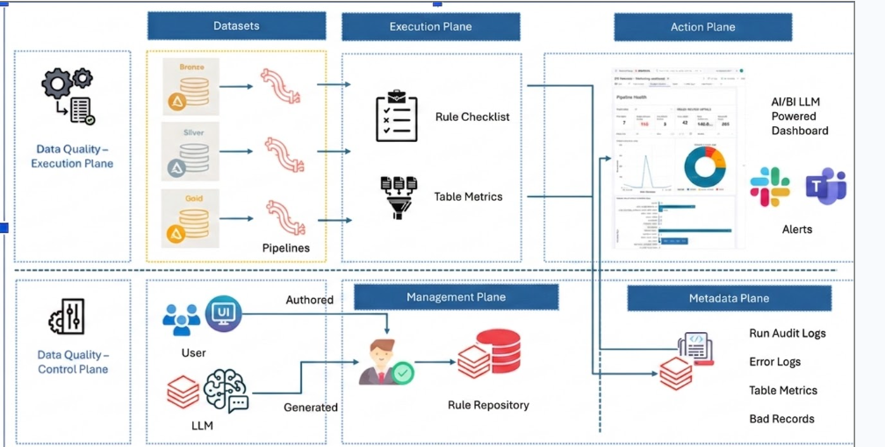

Architecture Diagram Summary: The architecture follows a flow where rules are defined in the Governance Pillar, processed by the Execution Pillar, and visualized/notified via the Observability Pillar
Pillar | Module | Function
Governance | Rule Management UI | User interface for rule creation, updates, and approvals.
Governance | LLM-Based Rule Suggester | AI-powered module that automatically analyzes table metadata, schema information, and column characteristics to recommend relevant Data Quality (DQ) rules.
Governance | Governance Schema | Database tables storing the state of rule requests and approved active rules.
Execution | "Data validator" Package | The core Python engine deployed in Databricks containing all validation logic.
Observability | Monitoring Schema | Database tables storing results, logs, metrics, and bad records.
Observability | DQ Dashboard | Visualization layer for profiling pipeline violations and table health.
Observability | Alerting Module | Integration with Email for proactive notifications on failures.

5.2 Business Benefits:
- Reduce Operational Costs: Dq check addressed at the bronze layer will reduce the cost as the bad records can be dropped or handled based on the requirement.
- Enable Trusted Reporting: Correct data results in correct reporting which will result in correct analysis and estimation of sales and other data
- Create a Single Source of Truth: Correct data will help us in building delta tables which can be a single source of truth and reliability.
- Ensure Regulatory Compliance: Consistent and proper data checks and monitoring will result in adherence to regular compliance.

6. Detailed Design

6.1 Execution Logic
The execution flow relies on a notebook or pipeline trigger that calls the core validation logic.
- Trigger: A pipeline/notebook calls the Run dq Checks functions.
- Fetch Rules: The function retrieves active rules from the DQ rules master Table (Governance Schema).
- Scan & Validate: The engine scans the target table (using partition columns for efficiency) and applies the logic.
- Log Results: The function writes pass/fail results, error logs, and metrics into the Monitoring Database Schema.

6.2 Automated Rule Generation (LLM Based)
To reduce manual effort, LakeWatch utilizes an LLM-powered rule suggestion capability.
- Input: Users submit a request through a Notebook interface for a specific table or dataset.
- Process: The LLM analyzes table metadata, schema information, column attributes, and profiling results to generate recommended Data Quality (DQ) rules, which are stored in the dq_rules table.
- Approval: Suggested rules enter an approval workflow where Data Engineers and Data Stewards review, modify if necessary, and approve them before they become active.
6.3 Rule Categories & Taxonomy
The framework supports a wide range of generic and business-specific checks:
- Completeness: Not Null, Blank, Must Have Value, Not Null Length Check
- Format & Pattern: Regex Match, Format Check, Length Check, Case Standardization
- Range & Threshold: Date Range, Timestamp Check, Value Threshold, Range Check, Outlier Detection
- Uniqueness: Duplicate Check, Unique Value Check
- Referential Integrity & Mapping: Foreign Key Check, Mapping Check
- Trend Analysis: Row Count Trend Check, KPI Metrics Check
- Custom Business Validation: Custom Business Rule

6.4 Rule Definitions
- Not Null
Purpose :Validates that the specified column does not contain NULL values.
Accepted Condition Criteria : This rule does not require any condition criteria.
- Blank Check
Purpose: Validates that the specified column contains a meaningful value and does not contain:
- NULL values
- Blank strings ('')
- Whitespace-only values
- Common null-equivalent placeholders such as NA, N/A, NULL, NONE, UNDEFINED, etc.
Accepted Condition Criteria: This rule does not require any condition criteria.
- Must Have Value
Purpose: Validates that the value in the specified column belongs to a predefined list of accepted values. Records containing values outside the allowed list are flagged as failures.
Accepted Condition Criteria
Key | Type | Required | Description
Value | List | Yes | List of acceptable values for the column

Example
{
"value": [0, 1, 2]
}
- Regex Match
Purpose: Validates that values in the specified column conform to a predefined regular expression (regex) pattern. This rule is used for custom or business-specific pattern validation. This rule is useful for validating structured data formats such as:
- Employee IDs (e.g., EMP-12345)
- Product codes
- Internal reference IDs
Accepted Condition Criteria
Key | Required | Description
regex_pattern | YES | Regular expression pattern used to validate column values

Example
{
"regex_pattern": "^[A-Z]{5}[0-9]{4}[A-Z]$"
}
- Format Check
Purpose : Validates that values in the specified column adhere to a defined data format using a regular expression pattern. This rule is commonly used to enforce standard formats for:
- Email addresses
- Phone numbers
- Postal/ZIP codes
- Account numbers
Accepted Condition Criteria

Key | Required | Description
regex_pattern | YES | Regular expression pattern used to validate column values

Example
{
"regex_pattern": "^[A-Za-z0-9._%+-]+@[A-Za-z0-9.-]+\\.[A-Za-z]{2,}$"
}
- Length Check
Purpose :Validates that the length of values in the specified column matches an expected character count after:
- Removing non-alphanumeric characters (special characters and punctuation)
- Trimming leading and trailing whitespace
- Ignoring NULL and configured null-equivalent placeholder values
Accepted Condition Criteria
Key | Type | Required | Description
value | Integer/Float | Yes | Expected character length after data cleaning

Example
{
"value": 10
}
- Date Range
Purpose: Validates that values in a specified date or timestamp column fall within a defined inclusive date range. This rule helps ensure the validity and consistency of temporal data such as transaction dates, event dates, record creation dates, and timestamps.
Accepted Condition Criteria

Key | Type | Required | Description
start_date | String | Yes | Lower bound of the valid date range (YYYY-MM-DD)
end_date | String | Yes | Upper bound of the valid date range (YYYY-MM-DD)

Example
{
"start_date": "2022-01-01",
"end_date": "2023-12-31"
}
- Timestamp Check
Purpose: Validates whether values in one or more date or timestamp columns satisfy a specified condition expression. This rule can be used to:
- Ensure timestamps fall within expected bounds.
- Validate event sequencing and chronological relationships.
- Enforce time-based business rules.
Accepted Condition Criteria
Key | Type | Required | Description
condition | String | Yes | SQL condition expression used to validate the date or timestamp column(s)

Example
{
"condition": "ship_date >= order_date"
}
- Value Threshold Check
Purpose: Validates that values in a specified numeric column satisfy a configured threshold condition. This rule helps enforce numeric boundaries and business limits, such as:
- Minimum allowed values
- Maximum allowed values
- Equality or inequality conditions
- Range validations through the combination of multiple threshold rules
Accepted Condition Criteria
Key | Type | Required | Description
operator | String | Yes | Comparison operator (>, >=, <, <=, =, !=)
value_threshold | Integer/Float | Yes | Numeric threshold value used for comparison

Example
{
"operator": ">",
"value_threshold": 100
}
- Duplicate Check
Purpose: Identifies duplicate records based on one or more specified columns. The rule detects rows where the combination of values in the selected column(s) appears more than once in the dataset.
Accepted Condition Criteria : This rule does not require any condition criteria.
- Unique Value Check
Purpose: Validates that each value in a specified column is uniquely associated with a single value in another identifier column. The rule identifies cases where the same value in the check column maps to multiple distinct values in the identifier column.
This rule is useful for detecting:
- Duplicate or conflicting mappings
- Violations of expected one-to-one relationships
- Data consistency issues across related attributes
Accepted Condition Criteria
Key | Type | Required | Description
identifier_column | String | Yes | Name of the column used to validate uniqueness against

Example
{
"identifier_column": "user_id"
}
- Row Count Trend Check
Purpose: Detects anomalies in the row count of a specified table by comparing the latest row count against historical row count statistics (mean and standard deviation) over a defined lookback period.
This rule helps identify:
- Unexpected spikes in data volume
- Significant drops in record counts
- Missing or incomplete data loads
- Potential pipeline or ingestion issues
Accepted Condition Criteria

Key | Type | Required | Description
interval | Integer | Yes | Number of days of historical data to use for trend analysis

Example
{
"interval": 30
}
- KPI Metrics Check
Purpose: Monitors KPI metrics by comparing the latest metric values against historical performance trends. The rule calculates statistical thresholds using historical valid data and identifies KPI values that fall outside expected bounds.
This rule helps identify:
- KPI anomalies and unexpected deviations
- Significant increases or decreases in business metrics
- Data quality issues impacting key business measures
- Potential operational or reporting inconsistencies
Accepted Condition Criteria
Key | Type | Required | Description
custom_query | String | Yes | SQL query used to calculate the KPI metric(s) to be monitored
upper_threshold | Integer | No | Upper threshold value for KPI metrics
lower_threshold | Integer | No | Lower threshold value for KPI metrics
interval | Integer | Yes | Number of recent days used to establish historical KPI trends

Example
{
"custom_query": "SELECT r_name AS metric_name, AVG(o_totalprice) AS metric_value FROM orders GROUP BY r_name",
"upper_threshold": 10000,
"lower_threshold": 100,
"interval": 30
}
- Case Standardization
Purpose: Detects values in a string column that are not standardized to a specified case format (UPPER or LOWER), ensuring consistency and uniformity in textual data.
Accepted Condition Criteria

Key | Type | Required | Description
case | String | Yes | Specifies the expected case format. Allowed values: UPPER, LOWER

Example:
{
"case": "UPPER"
}
- Mapping Check
Purpose: Validates that the values in a specified column conform to a defined set of canonical values after resolving known alias variants using an alias mapping logic (e.g., mapping values like 'us', 'america' → 'usa').
Accepted Condition Criteria

Key | Type | Required | Description
value | List | Yes | List of canonical (standardized) values that are valid after alias resolution

Example:
{
"value": ["usa", "canada", "mexico"]
}
- Outlier Detection
Purpose: Identifies numeric outliers in a column based on statistical deviation from the mean. A value is considered an outlier if it lies outside the range:
[mean − k × standard deviation, mean + k × standard deviation]
This rule is useful for detecting:
- Abnormal financial transactions
- Sensor/data anomalies
- Data entry or processing errors
- Significant deviations from expected trends
Accepted Condition Criteria
Key | Type | Required | Description
value | Integer/Float | Yes | Standard deviation multiplier (k) used to define outlier sensitivity

Example:
{
"value": 3
}
- Range Check
Purpose: Validates that numeric values in a specified column fall within a defined inclusive range like age,prices
Accepted Condition Criteria
Key | Type | Required | Description
min_value | Integer/Float | Yes | Minimum acceptable value
max_value | Integer/Float | Yes | Maximum acceptable value

Example:
{
"min_value": 10,
"max_value": 100
}
- Not Null Length Check
Purpose: Validates that values in a specified column are both present and conform to a fixed expected length. The rule excludes NULL values
Accepted Condition Criteria
Key | Type | Required | Description
value | Integer/Float | Yes | Expected character length of the column after excluding null and placeholder values

Example:
{
"value": 12
}
- Custom Business Rule
Purpose: Allows users to define and execute a fully custom SQL-based data quality check based on specific business rules. This enables validation of complex or domain-specific logic that cannot be expressed using standard predefined rules.
It provides maximum flexibility for:
- Complex business validations
- Domain-specific constraints
Accepted Condition Criteria :
Key | Type | Required | Description
custom_query | String | Yes | SQL query used for validation. Supports dynamic placeholders: {catalog_name}, {schema_name}, {table_name}
Example:
{
"custom_query": "SELECT c_custkey, c_name, c_mktsegment, c_acctbal FROM {catalog_name}.{schema_name}.{table_name} WHERE c_mktsegment IN ('AUTOMOBILE', 'BUILDING', 'FURNITURE') AND c_acctbal < 0"
}

6.5 Error Handling & Remediation
To ensure flexibility across different environments (Dev vs. Prod), the framework currently handles records that fail Data Quality (DQ) checks using a quarantine-based approach.
- Quarantine (Default): Records that fail DQ validations are isolated into a dedicated Quarantine Table for audit, monitoring, and root cause analysis (RCA). The pipeline continues processing valid records, ensuring uninterrupted data ingestion while preserving failed records for investigation, remediation, and potential reprocessing.

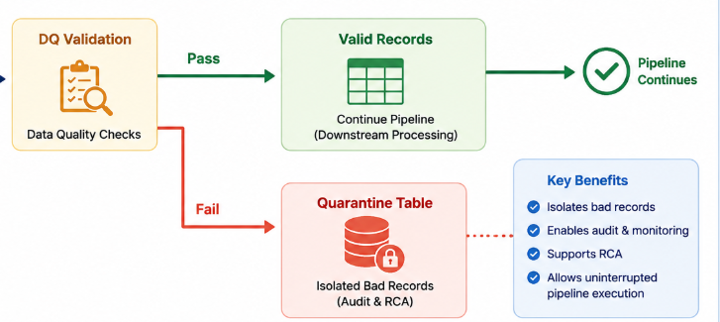

6.6 Schema Evolution
The framework is able to detect the change in schema from the previous version and would record that in the metric table. Eg: if there is any new column addition in the table, it will be detected and recorded in the metric table in the catalog.

7. Observability and Alerting

7.1 Dashboarding
A Databricks-native dashboard provides a unified view of pipeline health.
- Pipeline Level: Tracks critical violation records, failed checks, and total bad records.
- Table Level: Provides a summary of passed vs. failed checks per table.
- Drill Down: Users can view specific "Violation Details" including Rule ID, Category, and Record Count.

7.2 Alerting Strategy
The alerting module ensures real-time notification of data issues.
- Channels: Email Integration.
- Triggers: Run summaries and pipeline failures.
- Goal: Proactive notification to allow for quick remediation.

Email Alert:
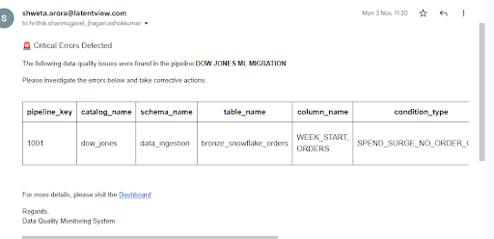

8. Implementation Plan

8.1 Setup
- Deploy the Governance Schema and Monitoring Schema to the Databricks environment.
- Install the data validator Python package.

8.2 Operational Workflow
- Define: Users define rules via the Management UI.
- Approve: Engineers approve rules, moving them to the Master Table.
- Run: Pipelines call run_dq_checks.
- Monitor: Dashboard is populated with results; Alerts fire on Critical failures.

8.3 CI/CD implementation
Deployment Strategy
- Pipeline Orchestration: The full LakeWatch framework — Governance, Execution, and Observability modules — is deployed using Azure DevOps CI/CD pipelines.
- DQ Job Scheduling: Data quality validations are executed through a dedicated, schedulable job. The job can be configured to run against all registered tables or a defined subset of tables based on business and operational requirements.

9. Appendix

1. Glossary and Acronyms

Quarantine: The state where bad records are isolated in a separate table rather than failing the pipeline.

2. Rule Categories
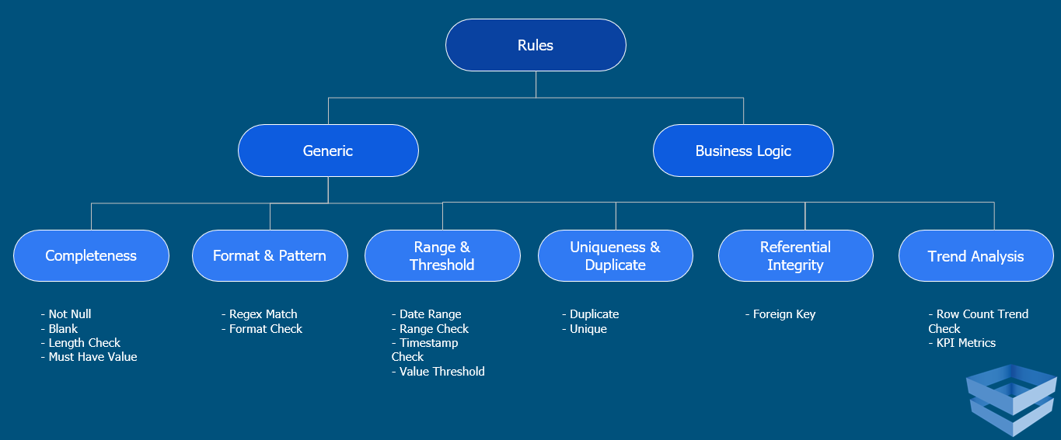

3. Lakewatch Dashboard
